THE ACADEMY OF ART UNIVERSITY

MODULE 14: INTO THE WOODS FINAL PROJECT

Tanya Hamner

PH 613: MS: COLOR AND LIGHT

Craig Dale

May 15, 2016

Tanya Hamner  
Craig Dale  
PH 613-OL1: MS Color and Light  
Assignment 7.1: Midterm

**Into the Woods**

**Introduction**

I walked down the sidewalk watching cars go by, honking and driving fast, and people yelling at each other. Car after car passed; there was no break in traffic. I suddenly stopped walking and looked around. The world started to circle around me. As I stared into the city, I began to wonder how did the world get to this point. How did it get to the point of selfishness, drugs, crime, and how did people get so wrapped up into time? I wondered if even I had lost myself to this world. I started running toward the woods as fast as I could, travelling further into the depths of the woods where reality couldn’t touch me anymore.

As I started running faster and further into the woods, I stumbled over a tree branch. I fell, and looked up to see nothing but trees surrounding me. The sky was so clear and circling. It started to get dark as I realized that I might be lost. But, am I lost in the woods or have I been so wrapped up that I lost myself in the world around me? I stared down the path and noticed my bags sitting at the pathway that waited for me to escape this world and start my new journey, my very own fairytale.  I realized that even though I escaped the world, time was still of the essence. I could not stop it from passing. I panicked as I realized that in the end I still had to go back to reality. I felt goose bumps and wondered what was scaring me, being in the darkening woods or going back to reality?

Light is one of the most important aspects in photography. Bruce Barnbaum writes in his book, The Art of Photography, “Light is the essence of photography. Knowledgeable photographers realize that they are not photographing objects, but rather light and the way it delinates objects or is imitted by them. Photography is the study of light, the perception of light and the interpretation of light.” Light reveals lines, forms, and shapes from the compositional elements that the photographer focuses on. (Barnbaum, 2010, p. 67)

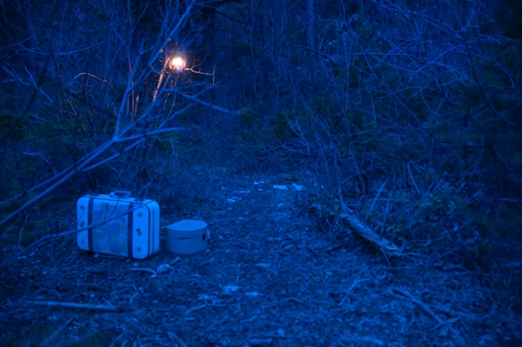When I started taking this class, Color and Light, I had never changed the white balance on my camera. I had always kept the white balance on auto.  At first it was a struggle to remember to change the white balance when I would photograph.  Before this class, I did not know much about how color and light would affect a photo. I never knew about the different color hues that could impact or change the mood of a photo.  As this class progressed, I began to learn how important color was to the message of the photograph. To create a sense of balance in my photographs I used warm and cool hues together. Warm and cool hues can be used together to create a sense of balance in your photograph. (Hirsch, Erf, 2011, p. 139) Before, I only knew about the golden hour and how it could cast a nice warm hue on your subject. I discovered this last semester in my Language of Photography class.  Half way through this semester, I decided to adventure into the color world. I changed my white balance and set the temperature to a cool temp 2700k to explore new messages. I discovered that this temperature at the time of dusk creates a beautiful ambient blue light. I learned throughout the semester that this ambient light combined with some warm colors creates a powerful image. By using this ambient blue lighting and my lantern, I have walked into assisted reality artistic involvement.  Most of the lighting came from the natural ambient light that is found in the woods. To add some contrast, I used side lighting from the warm lantern in the photos.

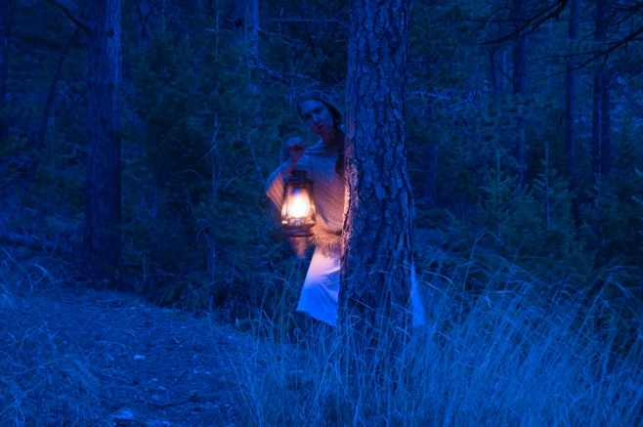 For the photos I used both soft and hard light. As I worked with my model, I noticed how soft the light was casting on her. To add a degree of contrast and light to the message, I had her carry my lantern. This created some hard light but not enough to overtake the soft light. I used a soft light from the ambient light for most of the images.  I used hard light in only a few photos to add some variety to the series since the ambient light creates a soft light among the model and the lantern adds a hard light to the photo. This contrast creates some tension to keep the viewer engaged.

When I was in the woods by myself, I could not help but feel a lonely feeling and, as dusk fell, I felt a sense of vulnerability. The woods started making sounds and scared me a little. To be able to express these feelings, I used a low contrast in the series.  Contrast can add energy to a photo.  The lower the contrast the more quietude or lethargy will play in the photograph. With dusk nearing, I felt that if I shot when the contrast from the ambient light was lessened then the photo would represent my message.  To create a lower contrast, I used spatial direction with the subjects, my camera, and the ambient light.

To bring more power to the photos, I created a layers mask in Photoshop and painted the subjects. I added some saturation to the warm tones and painted the saturation into the warmer colors. This made my subjects pop in the blue light. I was able to develop plasticity to make the ambient blue work.

Throughout the series, one of my main goals was to maintain consistency through the hues. In all of the photographs I used cool and neutral hues. To add some variety to the series, I used warm hues in some of the works. I noticed that when I used the warm hues against the cool hues the subjects really popped. It created a balance to the photo.

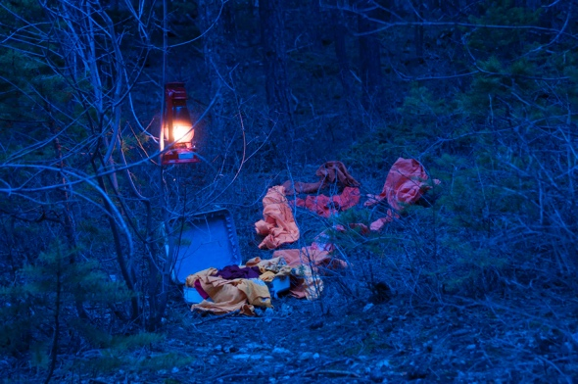I created a style using a short lens throughout this series to extend the distance between objects. This allowed the images to narrate a meaning. I maintained a consistent composition from lower left to upper right.  Using my style, I kept the most important part of the subject at a mid-top level. I have also developed a style using nature to create color cast.  For this series I used nature’s light to create an ambient blue lighting.

Color theory has opened my eyes to a new world of photography. I have never experienced warm and cold hues that appear together in a photo. I have never noticed before how one’s emotions and moods can be affected and changed depending on the hue used.

Works Cited

Barnbaum, Bruce. *The Art of Photography: An Approach to Personal Expression*. Santa Barbara,   
 CA: Rocky Nook, 2010. Print.

Hirsch, Robert, and Greg Erf. *Exploring Color Photography: From Film to Pixels*. 6th ed.   
 Oxford: Elsevier Focal, 2011. Print.